National Anthem of India
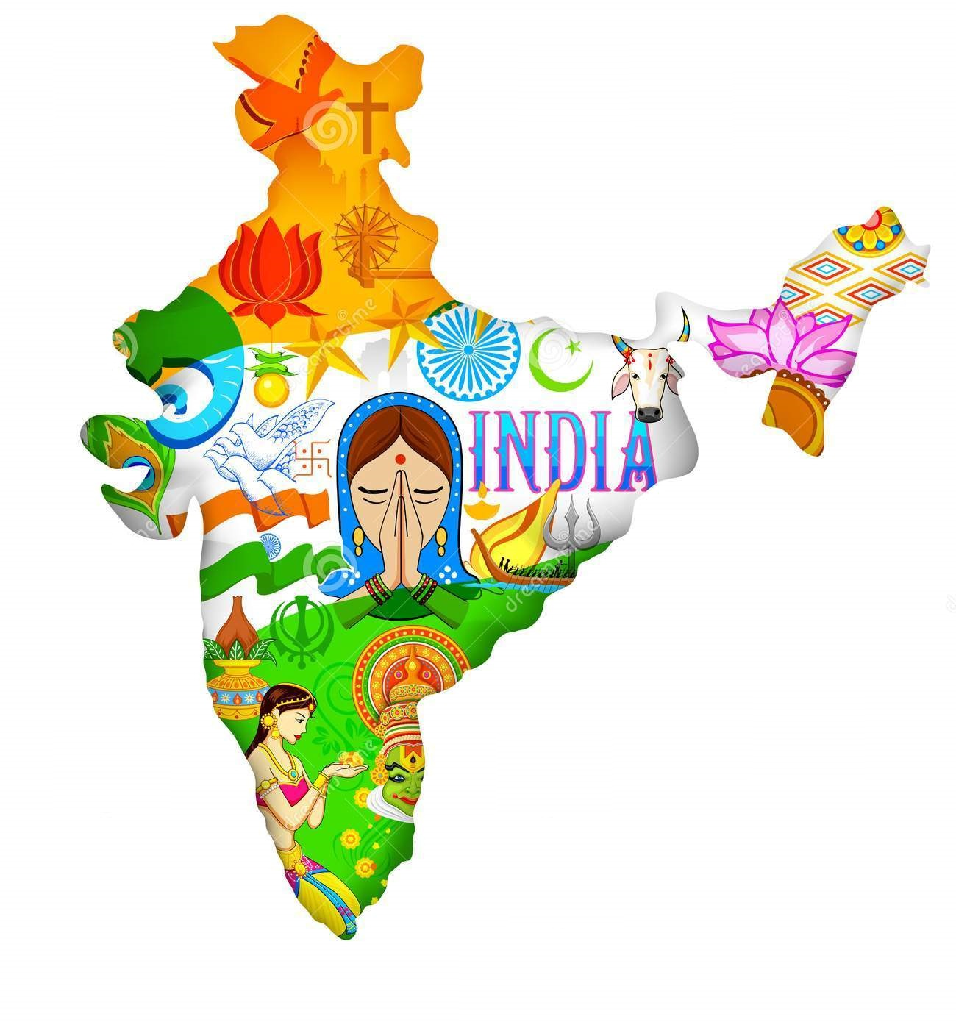
জনগণমন-অধিনায়ক জয় হে ভারতভাগ্যবিধাতা!
পঞ্জাব সিন্ধু গুজরাট মরাঠা দ্রাবিড় উত্কল বঙ্গ
বিন্ধ্য হিমাচল যমুনা গঙ্গা উচ্ছলজলধিতরঙ্গ
তব শুভ নামে জাগে, তব শুভ আশিষ মাগে,
গাহে তব জয়গাথা।
জনগণমঙ্গলদায়ক জয় হে ভারতভাগ্যবিধাতা!
জয় হে, জয় হে, জয় হে, জয় জয় জয় জয় হে॥

Jana Gana Mana Adhinaayak Jaya Hey,
Bhaarat Bhaagya Vidhaataa
Panjaab Sindhu Gujarat Maraatha,
Draavid Utkal Banga
Vindhya Himaachal Yamuna Ganga,
Uchchhal Jaladhi Taranga
Tav Shubh Naamey Jaagey,
Tav Shubh Aashish Maange
Gaahey Tav Jayagaathaa
Jana Gana Mangal Daayak,
Jaya Hey Bhaarat Bhaagya Vidhaataa
Jaya Hey, Jaya Hey, Jaya Hey,
Jaya Jaya Jaya, Jaya Hey

Herrscher über den Geist des Volkes, Heil Dir,
Indiens Schicksalslenker!
Punjab, Sindh, Gujarat, Maratha,
Dravida, Utkal und Bengalen,
das Vindhya-Gebirge, der Himalaya, die Yamuna, der Ganges,
die hohen Wogen des Ozeans,
erwachen durch deinen glückverheißenden Namen,
erbitten deinen glückverheißenden Segen,
singen dein Siegeslied.
Glückbringer des Volkes, Heil Dir,
Indiens Schicksalslenker!
Deutsche Schule New Delhi
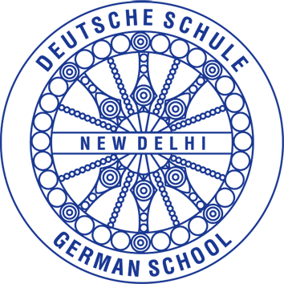
German School New Delhi

Schulfest 2018
School festival 20118
 | Programm | Program
14.30 | Einlass | Gates open
15.00 | Eröffnung Nationalhymne, KiGa-Darbietung, Bollywoodtanz der Grundschule | Opening ceremony  National anthem, KiGa-presentation and primary Bollywood dance
 | Schulfoto | school picture
15.30 | Spiele  und Kaffee | Activities  and Coffee
17.30 | AG-Darbietungen | Club presentation
19.00 | Abendessen | Dinner
19.30 | Musik  Schulband | Music by Staff Schoolband
22.30 | Ende | End

Spielepass Activities passport

Kindergarten Verrücktes Passfoto
Crazy picture
Klasse 5 Glücksrad
Grade 5 Wheel of fortune

Klasse 6 Sari-Lauf
Grade 6 Sari race

Klasse 7 Gewürze
Grade 7 spices

Klasse 8 Rangoli
Grade 8 Rangoli

Klasse 9 indisches Tabu
Grade 9 Indian Taboo

Klasse 10 Musik
Grade 10 Music

Klasse 11 „Holi“ Farbenspaß
Grade 11 “Holi“ fun with colours

